Artificial Intelligence Project Based Learning (PBL) Report on
AI-Integrated Patient Monitoring System using Bayesian Reasoning
Submitted in partial fulfilment of the
Requirements for the award of the degree of

BACHELOR OF TECHNOLOGY

IN
COMPUTER SCIENCE AND ENGINEERING
(ARTIFICIAL INTELLIGENCE & MACHINE LEARNING)

Submitted by
Kuppili Nikhilesh Raju (23R11A66H7)

Under the esteemed guidance of
Mr. Shaik Akbar

Associate Professor, CSE (AI & ML) Department, GCET

GEETHANJALI COLLEGE OF ENGINEERING AND TECHNOLOGY
Department of Computer Science and Engineering (AI & ML)
(UGC Autonomous)
(Accredited by NAAC with A+ Grade, Approved by AICTE and
Affiliated to JNTUH Cheeryal (V), Keesara (M), Medchal (Dist), Telangana – 501 301.
October – 2025

GEETHANJALI COLLEGE OF ENGINEERING AND TECHNOLOGY
Department of Computer Science and Engineering (AI & ML)
(UGC Autonomous)
(Accredited by NAAC with A+ Grade , Approved by AICTE and Affiliated to JNTUH Cheeryal (V), Keesara (M), Medchal (Dist), Telangana – 501 301.

DERPARTMENT OF COMPUTER SCIENCE AND ENGINEERING
(AI & ML)

CERTIFICATE

This is to certify that the Artificial Intelligence Project Based Learning (PBL) Report entitled “AI-Integrated Patient Monitoring System using Bayesian Reasoning“ is a Bonafide work done and submitted by Kuppili Nikhilesh Raju (23R11A66H7), during the academic year 2025– 2026, in partial fulfilment of the requirement for the award of Bachelor of Technology degree in “Computer Science and Engineering (AI&ML)” from Geethanjali College of Engineering and Technology (Accredited by NAAC with “A+" Grade, Approved by AICTE and Affiliated to JNTUH), is a Bonafide record of work carried out by them under guidance and supervision.
Certified further that to the best of my knowledge, the work in this project has not been submitted to any other institution for the award of any degree or diploma.

FACULTY GUIDE
Mr. Shaik Akbar
Professor
CSE-AIML Department
i
DECLARATION

We hereby declare that the project report entitled “AI-Integrated Patient Monitoring System using Bayesian Reasoning” is an original work done and submitted to CSE(AI&ML) Department, from Geethanjali College of Engineering and Technology (Accredited by NAAC with “A+” Grade & NBA, Approved by AICTE and Affiliated to JNTUH), in partial fulfilment of the requirement for the award of Bachelor of Technology in “Computer Science and Engineering (AI&ML)” and it is a record of Bonafide project work carried out by us under the guidance of Mr. Shaik Akbar, Associate Professor, Department of CSE(AI&ML).

Signature of the Student
Kuppili Nikhilesh Raju
(23R11A66H7)

ii
ACKNOWLEDGEMENT

The successful culmination of this project wouldn't be complete without expressing our heartfelt appreciation for the invaluable support extended to us by numerous individuals. We extend our sincerest gratitude to those whose guidance and encouragement played a pivotal role in bringing this endeavour to fruition.
Foremost, we extend our gratitude to the Chairman, Principal, and Vice Principal for their unwavering support in facilitating the necessary infrastructure for the timely completion of this project.

Our deepest appreciation goes to Mr. Shaik Akbar, our esteemed faculty guide and Associate Professor in the CSE(AI&ML) Department at Geethanjali College of Engineering and Technology.
His unwavering support, timely cooperation, and invaluable advice have been instrumental throughout our project's journey.

Dr. A. Nageshwara Rao, the Head of Department, deserves our heartfelt thanks for his meticulous attention and continuous support during the entire project duration.
Additionally, our gratitude extends to all the project Coordinators whose unwavering guidance ensured a smooth progression of our work, overcoming obstacles effortlessly.
To each individual who contributed in ways seen and unseen, your support has been invaluable and has truly made a difference in the successful completion of this project.

iii
ABSTRACT

The project KogniCare – AI-Integrated Patient Monitoring System using Bayesian Reasoning demonstrates how artificial intelligence can enhance modern healthcare through real-time probabilistic diagnosis and uncertainty management. By leveraging Bayesian Networks, the system continuously analyses patient vitals such as heart rate, temperature, and oxygen saturation to estimate the probability of medical conditions like sepsis, heart failure, and respiratory distress. It integrates a Python Flask backend, a Bayesian inference engine, and a responsive web dashboard for real-time visualization and decision support.
The system provides confidence-aware alerts, explainable AI reasoning, and automated medical reports, ensuring accurate, transparent, and proactive patient monitoring. KogniCare showcases how AI-based probabilistic reasoning can improve clinical reliability, reduce false alarms, and assist healthcare professionals in making informed decisions under uncertainty.

Keywords: Artificial Intelligence, Bayesian Networks, Probabilistic Reasoning, Healthcare Monitoring, Flask, Real-time Diagnosis, Uncertainty Management, Explainable AI, Patient Monitoring System, Medical Decision Support

iv
LIST OF FIGURES
- Figure 5.1 – Patient Information and Live Vital Signs
- Figure 5.2 – Vital Signs Trends and Bayesian Network Analysis
- Figure 5.3 and 5.4 – AI Video Analytics and Real Time Alerts

v
TABLE OF CONTENTS

I | Certificate Page | i
II | Declaration | ii
III | Acknowledgment | iii
IV | Abstract | iv
V | List of figures | v
VI | Table of contents | vi

1 | INTRODUCTION | 1
2 | AIM AND OBJECTIVES | 2
2.1 | Aim of Proposed System | 2
2.2 | Objectives of Proposed Project | 2
3 | IMPLEMENTATION | 5
4 | SAMPLE CODE | 9
5 | OUTPUT SCREENS | 25
6 | CONCLUSION | 27
7 | BIBLIOGRAPHY | 28

vi
- INTRODUCTION

In today’s healthcare environment, timely and accurate patient monitoring is essential for preventing medical emergencies and improving patient outcomes. Traditional monitoring systems primarily rely on threshold-based alerts, which often result in high false alarm rates and lack the ability to reason under uncertainty. To overcome these limitations, the integration of Artificial Intelligence (AI) and probabilistic reasoning has emerged as a transformative approach in modern healthcare.
KogniCare is designed to address these challenges by implementing Bayesian Networks for probabilistic diagnosis and real-time inference. The system continuously observes patient vitals such as heart rate, oxygen saturation (SpO₂), temperature, and respiratory rate, using them as evidence to calculate the likelihood of conditions like heart failure, sepsis, and respiratory distress.
The project emphasizes uncertainty management, which allows the AI to make rational decisions even when medical data is incomplete or noisy—a common scenario in real-world hospital environments. By combining Flask-based web architecture, probabilistic reasoning, and interactive visualization, KogniCare provides an intelligent, explainable, and scalable healthcare solution.
This integration of probabilistic AI models not only enhances diagnostic reliability but also supports medical professionals with interpretable insights, enabling faster and more informed clinical decisions. KogniCare thus represents a step toward data-driven, proactive, and transparent healthcare systems that can adapt to complex and uncertain patient data in real time.

1
- AIM AND OBJECTIVES

2.1 Aim of Proposed Project
The aim of the proposed project “KogniCare – AI-Integrated Patient Monitoring System using Bayesian Reasoning” is to design and develop an intelligent healthcare monitoring system that utilizes probabilistic reasoning through Bayesian Networks to analyze patient health data in real time.
The project seeks to enhance the reliability and efficiency of patient monitoring by:
- Managing uncertainty in medical data using probabilistic models.
- Providing real-time diagnosis and risk assessment for critical conditions.
- Delivering explainable AI-based recommendations to assist healthcare professionals in decision-making.
- Minimizing false alarms and improving overall patient safety through confidence-aware alerts.
By integrating AI, probabilistic inference, and modern web technologies, KogniCare aims to create a robust, transparent, and scalable system that supports intelligent healthcare monitoring and proactive medical intervention.

2.2 Objective of Proposed Project
The main objective of the proposed project “KogniCare – AI-Integrated Patient Monitoring System” is to develop an intelligent healthcare monitoring system that applies Bayesian probabilistic reasoning to analyze and interpret patient vital signs in real time.
The system aims to assist healthcare professionals by:
- Managing uncertainty in medical data using Bayesian Networks.
- Performing real-time medical diagnosis and risk assessment.

2
- Providing explainable AI-based insights for better clinical decision-making.
- Minimizing false alarms through confidence-based alert mechanisms.
- Enhancing patient safety and treatment accuracy through continuous monitoring.
Ultimately, KogniCare strives to bridge the gap between artificial intelligence and healthcare by delivering a transparent, reliable, and data-driven diagnostic support system.

Project Highlights:
- AI-Powered Healthcare Monitoring:
KogniCare integrates artificial intelligence to continuously monitor patient vitals such as heart rate, SpO₂, temperature, and respiratory rate for real-time health assessment.
- Bayesian Network Implementation:
The system employs Bayesian Networks for probabilistic reasoning, enabling intelligent diagnosis even when medical data is incomplete or uncertain.
- Uncertainty Management:
By quantifying uncertainty using entropy-based measures, the system provides confidence levels for each diagnosis, improving clinical reliability.
- Explainable AI (XAI):
KogniCare ensures transparency by explaining its diagnostic reasoning, making AI decisions understandable to healthcare professionals.
- Hybrid AI Integration:
Combines Bayesian reasoning with a Large Language Model (Microsoft Phi-3.5 Mini) for intelligent, conversational medical assistance.
- Real-time Data Processing:
The system performs live inference and updates patient status every few seconds, offering immediate detection of abnormalities.
- Interactive Web Dashboard:
Features a modern, user-friendly interface for visualizing vital signs, probability distributions, and alerts in real time.

3
- Confidence-Aware Alerts:
Reduces false alarms by using probabilistic thresholds to classify alerts as normal, warning, or critical.
- Automated Reporting:
Generates professional PDF reports summarizing patient data, diagnostic probabilities, and uncertainty levels for medical documentation.

4
- IMPLEMENTATION

The KogniCare – AI-Integrated Patient Monitoring System is implemented using a modular architecture that combines AI-based probabilistic reasoning, real-time data simulation, and web-based visualization. The implementation demonstrates how Bayesian Networks can be used to manage uncertainty in medical diagnosis and assist healthcare professionals with explainable, data-driven insights.

3.1 System Architecture
The project follows a modular architecture divided into three primary layers:
- Frontend Layer (User Interface):
  - Developed using HTML5, CSS3, and JavaScript.
  - Displays live vital signs, probability graphs, and alerts.
  - Integrated with Chart.js for real-time visualization of Bayesian inference results.
- Backend Layer (Core Processing):
  - Built using Python Flask as the web framework.
  - Contains the Bayesian Network, AI services, and data processing modules.
  - Manages patient data, probabilistic computations, and API endpoints.
- AI Layer (Probabilistic Reasoning & NLP):
  - Implements Bayesian Networks for probabilistic diagnosis.
  - Integrates Microsoft Phi-3.5 Mini LLM via OpenRouter API for explainable medical assistance.
  - Provides uncertainty quantification and reasoning explanations.

5
3.2 Core Implementation Modules
- bayesian_network.py – Bayesian Model:
  - Implements nodes for Heart Rate, SpO₂, Temperature, and Respiratory Rate.
  - Defines relationships between these vitals and medical conditions such as Heart Failure, Sepsis, and Respiratory Distress.
  - Uses Conditional Probability Tables (CPTs) for probabilistic reasoning and dynamic inference.
- vitals_service.py – Vitals Simulation:
  - Generates realistic, time-varying vital sign data.
  - Simulates real-time patient monitoring with 5–30 second updates.
  - Produces anomalies to trigger alerts and test diagnostic responses.
- uncertainty_service.py – Bayesian Analysis Engine:
  - Performs probabilistic inference using Bayesian Networks.
  - Computes entropy-based uncertainty and confidence scores.
  - Provides the final diagnostic probabilities for visualization.
- ai_service.py – LLM Integration:
  - Connects to Microsoft Phi-3.5 Mini (via OpenRouter API).
  - Handles medical queries and explains Bayesian reasoning in natural language.
  - Offers context-aware responses combining AI reasoning with probabilistic insights.
- report_service.py – PDF Report Generator:
  - Generates professional reports summarizing patient vitals, diagnosis probabilities, and uncertainty levels using ReportLab.

6
- app.py – Main Application Controller:
  - Initializes the Flask app and registers all modules and routes.
  - Connects frontend and backend layers for smooth real-time operation.
  - Hosts API endpoints for vital data, Bayesian results, and AI chat services.
3.3 Frontend Implementation
- The user interface is built using HTML, CSS, and JavaScript, featuring:
  - Real-time Charts using Chart.js to display live vitals and probabilities.
  - Bayesian Analysis Panel showing probability distributions and confidence levels.
  - AI Chat Interface for user interaction with the medical assistant.
  - Responsive Design to ensure accessibility across desktop and mobile devices.
3.4 Execution Workflow
- Vitals Simulation: The system generates continuous vital sign data.
- Bayesian Inference: The data is passed into the Bayesian Network for probabilistic diagnosis.
- Uncertainty Estimation: Confidence scores and entropy values are calculated.
- AI Integration: The LLM interprets results and provides medical explanations.
- Visualization: Results are displayed in real time on the web dashboard.
- Reporting: PDF reports can be generated for patient documentation.
3.5 Output
- Dashboard Output:
  - Displays live health metrics, probabilistic diagnoses, and alert statuses.

7
- AI Chat Output:
  - Provides context-aware medical explanations with confidence levels.
- PDF Report Output:
  - Summarizes diagnostic probabilities, confidence scores, and trends.

8
- SAMPLE CODE

import numpy as np
from itertools import product
import math
from typing import Dict, List, Tuple, Any, Optional
import random

class BayesianNode:
def __init__(self, name: str, states: List[str], parents: List[str] = None):
self.name = name
self.states = states
self.parents = parents or []
self.cpt = {} # Conditional Probability Table
def set_cpt(self, cpt: Dict):
"""Set the conditional probability table for this node"""
self.cpt = cpt
def get_probability(self, state: str, parent_states: Dict = None):
"""Get probability P(state | parent_states)"""
if not self.parents:
return self.cpt.get(state, 0.0)
parent_key = tuple(parent_states.get(parent, None) for parent in self.parents)
return self.cpt.get(parent_key, {}).get(state, 0.0)

9
class BayesianNetwork:
def __init__(self):
self.nodes = {}
self.edges = []
def add_node(self, node: BayesianNode):
"""Add a node to the network"""
self.nodes[node.name] = node
def add_edge(self, parent: str, child: str):
"""Add an edge between nodes"""
if child in self.nodes and parent in self.nodes:
if parent not in self.nodes[child].parents:
self.nodes[child].parents.append(parent)
self.edges.append((parent, child))
def query(self, query_var: str, evidence: Dict = None) -> Dict[str, float]:
"""Perform exact inference using enumeration"""
evidence = evidence or {}
query_node = self.nodes[query_var]
# Calculate P(query_var = state | evidence) for each state
probabilities = {}
for state in query_node.states:
# Add query variable to evidence
extended_evidence = evidence.copy()
extended_evidence[query_var] = state

10
# Calculate joint probability
prob = self._enumerate_all(list(self.nodes.keys()), extended_evidence)
probabilities[state] = prob
# Normalize probabilities
total = sum(probabilities.values())
if total > 0:
probabilities = {k: v/total for k, v in probabilities.items()}
return probabilities
def _enumerate_all(self, vars_list: List[str], evidence: Dict) -> float:
"""Enumerate all possible assignments to calculate joint probability"""
if not vars_list:
return 1.0
var = vars_list[0]
rest = vars_list[1:]
if var in evidence:
# Variable is assigned in evidence
prob = self._get_conditional_prob(var, evidence[var], evidence)
return prob * self._enumerate_all(rest, evidence)
else:
# Sum over all possible values
total = 0.0
for state in self.nodes[var].states:
extended_evidence = evidence.copy()

11
extended_evidence[var] = state
prob = self._get_conditional_prob(var, state, extended_evidence)
total += prob * self._enumerate_all(rest, extended_evidence)
return total
def _get_conditional_prob(self, var: str, state: str, evidence: Dict) -> float:
"""Get P(var = state | parents)"""
node = self.nodes[var]
if not node.parents:
return node.cpt.get(state, 0.0)
parent_states = {parent: evidence.get(parent) for parent in node.parents}
return node.get_probability(state, parent_states)
class MedicalBayesianNetwork:
def __init__(self):
self.network = BayesianNetwork()
self.setup_medical_network()
def setup_medical_network(self):
"""Setup the medical diagnosis Bayesian network"""
# Define nodes with their possible states
nodes_config = {
'heart_rate': ['low', 'normal', 'high'],
'spo2': ['low', 'normal', 'high'],
'temperature': ['low', 'normal', 'high'],
'respiratory_rate': ['low', 'normal', 'high'],

12
'heart_failure': ['absent', 'mild', 'severe'],
'sepsis': ['absent', 'mild', 'severe'],
'respiratory_distress': ['absent', 'mild', 'severe'],
'patient_status': ['stable', 'at_risk', 'critical']
}
# Create nodes
for name, states in nodes_config.items():
if name in ['heart_rate', 'spo2', 'temperature', 'respiratory_rate']:
# Evidence nodes (no parents)
node = BayesianNode(name, states)
elif name in ['heart_failure', 'sepsis', 'respiratory_distress']:
# Condition nodes (dependent on vital signs)
parents = ['heart_rate', 'spo2', 'temperature', 'respiratory_rate']
node = BayesianNode(name, states, parents)
else:
# Patient status (dependent on all conditions)
parents = ['heart_failure', 'sepsis', 'respiratory_distress']
node = BayesianNode(name, states, parents)
self.network.add_node(node)
# Add edges
vital_signs = ['heart_rate', 'spo2', 'temperature', 'respiratory_rate']
conditions = ['heart_failure', 'sepsis', 'respiratory_distress']
for vital in vital_signs:

13
for condition in conditions:
self.network.add_edge(vital, condition)
for condition in conditions:
self.network.add_edge(condition, 'patient_status')

# Set up CPTs (Conditional Probability Tables)
self._setup_cpts()
def _setup_cpts(self):
"""Setup conditional probability tables based on medical knowledge"""
# Prior probabilities for vital signs (evidence nodes)
self.network.nodes['heart_rate'].set_cpt({
'low': 0.15,
'normal': 0.70,
'high': 0.15
})
self.network.nodes['spo2'].set_cpt({
'low': 0.10,
'normal': 0.85,
'high': 0.05
})
self.network.nodes['temperature'].set_cpt({
'low': 0.05,
'normal': 0.85,

14
'high': 0.10
})
self.network.nodes['respiratory_rate'].set_cpt({
'low': 0.10,
'normal': 0.80,
'high': 0.10
})
# Heart Failure CPT (based on heart rate and SpO2 primarily)
heart_failure_cpt = {}
for hr, spo2, temp, rr in product(['low', 'normal', 'high'], repeat=4):
key = (hr, spo2, temp, rr)
# Calculate probabilities based on medical knowledge
if hr == 'high' and spo2 == 'low':
probs = {'absent': 0.2, 'mild': 0.5, 'severe': 0.3}
elif hr == 'high' or spo2 == 'low':
probs = {'absent': 0.4, 'mild': 0.4, 'severe': 0.2}
elif hr == 'low' and spo2 == 'normal':
probs = {'absent': 0.6, 'mild': 0.3, 'severe': 0.1}
else:
probs = {'absent': 0.8, 'mild': 0.15, 'severe': 0.05}
heart_failure_cpt[key] = probs
self.network.nodes['heart_failure'].set_cpt(heart_failure_cpt)

15
# Sepsis CPT (based on temperature and heart rate primarily)
sepsis_cpt = {}
for hr, spo2, temp, rr in product(['low', 'normal', 'high'], repeat=4):
key = (hr, spo2, temp, rr)
if temp == 'high' and hr == 'high':
probs = {'absent': 0.1, 'mild': 0.4, 'severe': 0.5}
elif temp == 'high' or hr == 'high':
probs = {'absent': 0.3, 'mild': 0.5, 'severe': 0.2}
elif temp == 'low':
probs = {'absent': 0.4, 'mild': 0.4, 'severe': 0.2}
else:
probs = {'absent': 0.85, 'mild': 0.12, 'severe': 0.03}
sepsis_cpt[key] = probs
self.network.nodes['sepsis'].set_cpt(sepsis_cpt)
# Respiratory Distress CPT
respiratory_cpt = {}
for hr, spo2, temp, rr in product(['low', 'normal', 'high'], repeat=4):
key = (hr, spo2, temp, rr)
if spo2 == 'low' and rr == 'high':
probs = {'absent': 0.1, 'mild': 0.3, 'severe': 0.6}
elif spo2 == 'low' or rr == 'high':
probs = {'absent': 0.3, 'mild': 0.5, 'severe': 0.2}

16
elif rr == 'low':
probs = {'absent': 0.6, 'mild': 0.3, 'severe': 0.1}
else:
probs = {'absent': 0.9, 'mild': 0.08, 'severe': 0.02}
respiratory_cpt[key] = probs
self.network.nodes['respiratory_distress'].set_cpt(respiratory_cpt)
# Patient Status CPT
status_cpt = {}
for hf, sepsis, rd in product(['absent', 'mild', 'severe'], repeat=3):
key = (hf, sepsis, rd)
severe_count = sum(1 for condition in [hf, sepsis, rd] if condition == 'severe')
mild_count = sum(1 for condition in [hf, sepsis, rd] if condition == 'mild')
if severe_count >= 2:
probs = {'stable': 0.05, 'at_risk': 0.15, 'critical': 0.8}
elif severe_count == 1:
probs = {'stable': 0.1, 'at_risk': 0.6, 'critical': 0.3}
elif mild_count >= 2:
probs = {'stable': 0.3, 'at_risk': 0.6, 'critical': 0.1}
elif mild_count == 1:
probs = {'stable': 0.7, 'at_risk': 0.25, 'critical': 0.05}
else:
probs = {'stable': 0.95, 'at_risk': 0.04, 'critical': 0.01}
status_cpt[key] = probs

17
self.network.nodes['patient_status'].set_cpt(status_cpt)
def classify_vitals(self, vitals: Dict[str, float]) -> Dict[str, str]:
"""Convert numerical vital signs to categorical states"""
classifications = {}
# Heart Rate classification
hr = vitals.get('heart_rate', 70)
if hr < 60:
classifications['heart_rate'] = 'low'
elif hr > 100:
classifications['heart_rate'] = 'high'
else:
classifications['heart_rate'] = 'normal'
# SpO2 classification
spo2 = vitals.get('spo2', 98)
if spo2 < 95:
classifications['spo2'] = 'low'
elif spo2 > 99:
classifications['spo2'] = 'high'
else:
classifications['spo2'] = 'normal'
# Temperature classification (Celsius)
temp = vitals.get('temperature', 37.0)

18
if temp < 36.0:
classifications['temperature'] = 'low'
elif temp > 37.5:
classifications['temperature'] = 'high'
else:
classifications['temperature'] = 'normal'
# Respiratory Rate classification
rr = vitals.get('respiratory_rate', 16)
if rr < 12:
classifications['respiratory_rate'] = 'low'
elif rr > 20:
classifications['respiratory_rate'] = 'high'
else:
classifications['respiratory_rate'] = 'normal'
return classifications
def update_with_vitals(self, vitals: Dict[str, float]) -> Dict[str, Any]:
"""Update the network with new vital signs and return inference results"""
# Classify vitals into categorical states
evidence = self.classify_vitals(vitals)
# Perform inference for all conditions and patient status
results = {}
# Query each condition
conditions = ['heart_failure', 'sepsis', 'respiratory_distress', 'patient_status']

19
for condition in conditions:
results[condition] = self.network.query(condition, evidence)
# Add uncertainty analysis
results['uncertainty_analysis'] = self._analyze_uncertainty(results)
# Add evidence used
results['evidence'] = evidence
results['raw_vitals'] = vitals
return results
def _analyze_uncertainty(self, results: Dict) -> Dict[str, Any]:
"""Analyze uncertainty in the predictions"""
uncertainty_metrics = {}
for condition, probabilities in results.items():
if isinstance(probabilities, dict):
# Calculate entropy (uncertainty measure)
entropy = -sum(p * math.log2(p) if p > 0 else 0
for p in probabilities.values())
# Calculate confidence (max probability)
max_prob = max(probabilities.values())
# Calculate certainty (1 - entropy/max_entropy)
max_entropy = math.log2(len(probabilities))
certainty = 1 - (entropy / max_entropy) if max_entropy > 0 else 1
uncertainty_metrics[condition] = {
'entropy': entropy,

20
'confidence': max_prob,
'certainty': certainty,
'most_likely': max(probabilities.items(), key=lambda x: x[1])
}
return uncertainty_metrics
def get_recommendations(self, analysis_results: Dict) -> List[str]:
"""Generate clinical recommendations based on Bayesian analysis"""
recommendations = []
# Check patient status
status_probs = analysis_results.get('patient_status', {})
critical_prob = status_probs.get('critical', 0)
at_risk_prob = status_probs.get('at_risk', 0)
if critical_prob > 0.5:
recommendations.append(" IMMEDIATE medical intervention required")
recommendations.append("Consider ICU admission")
elif at_risk_prob > 0.4:
recommendations.append(" Increase monitoring frequency")
recommendations.append("Prepare for potential deterioration")
# Check specific conditions
hf_probs = analysis_results.get('heart_failure', {})
if hf_probs.get('severe', 0) > 0.3:
recommendations.append(" Consider echocardiogram and BNP testing")
recommendations.append("Monitor fluid balance closely")

21
sepsis_probs = analysis_results.get('sepsis', {})
if sepsis_probs.get('severe', 0) > 0.3:
recommendations.append(" Initiate sepsis protocol immediately")
recommendations.append("Obtain blood cultures and start antibiotics")
rd_probs = analysis_results.get('respiratory_distress', {})
if rd_probs.get('severe', 0) > 0.3:
recommendations.append(" Consider arterial blood gas analysis")
recommendations.append("Assess need for respiratory support")
# Uncertainty-based recommendations
uncertainty = analysis_results.get('uncertainty_analysis', {})
high_uncertainty_conditions = [
condition for condition, metrics in uncertainty.items()
if isinstance(metrics, dict) and metrics.get('certainty', 1) < 0.6
]
if high_uncertainty_conditions:
recommendations.append(f" High uncertainty detected in: {', '.join(high_uncertainty_conditions)}")
recommendations.append("Consider additional diagnostic tests")
if not recommendations:
recommendations.append(" Continue current monitoring protocol")
recommendations.append("Patient appears stable based on current data")
return recommendations

22
# Example usage and testing
if __name__ == "__main__":
# Create the medical Bayesian network
medical_net = MedicalBayesianNetwork()
# Example patient vitals
test_vitals = {
'heart_rate': 110, # High
'spo2': 92, # Low
'temperature': 38.5, # High
'respiratory_rate': 25 # High
}
print(" Medical Bayesian Network Analysis")
print("=" * 50)
# Analyze the patient
results = medical_net.update_with_vitals(test_vitals)
print(f"\n Patient Vitals:")
for vital, value in test_vitals.items():
classification = results['evidence'][vital]
print(f" • {vital.replace('_', ' ').title()}: {value} ({classification})")
print(f"\n Bayesian Analysis Results:")
conditions = ['heart_failure', 'sepsis', 'respiratory_distress', 'patient_status']
for condition in conditions:
probs = results[condition]

23
uncertainty = results['uncertainty_analysis'][condition] print(f"\n{condition.replace('_', ' ').title()}:")
for state, prob in probs.items():
print(f" • {state.capitalize()}: {prob:.3f} ({prob*100:.1f}%)")
print(f" Confidence: {uncertainty['confidence']:.3f}")
print(f" Certainty: {uncertainty['certainty']:.3f}")
print(f" Most Likely: {uncertainty['most_likely'][0]} ({uncertainty['most_likely'][1]:.3f})")
print(f"\n Clinical Recommendations:")
recommendations = medical_net.get_recommendations(results)
for i, rec in enumerate(recommendations, 1):
print(f" {i}. {rec}")
print(f"\n Summary:")
status_result = results['uncertainty_analysis']['patient_status']['most_likely']
print(f"Patient Status: {status_result[0].upper()} (confidence: {status_result[1]:.3f})")

24
- OUTPUT SCREENS

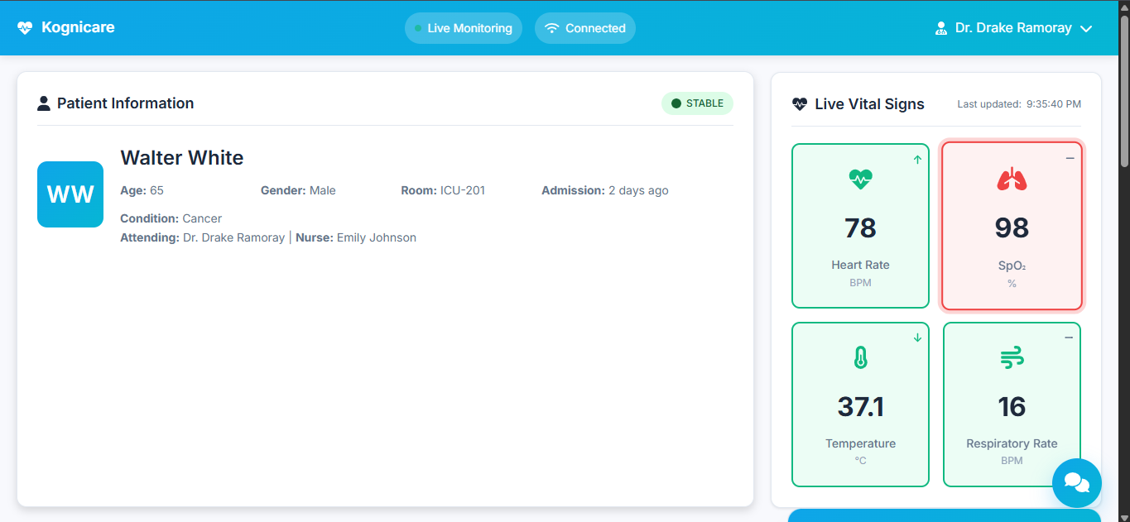
Figure 5.1 – Patient Information and Live Vital Signs
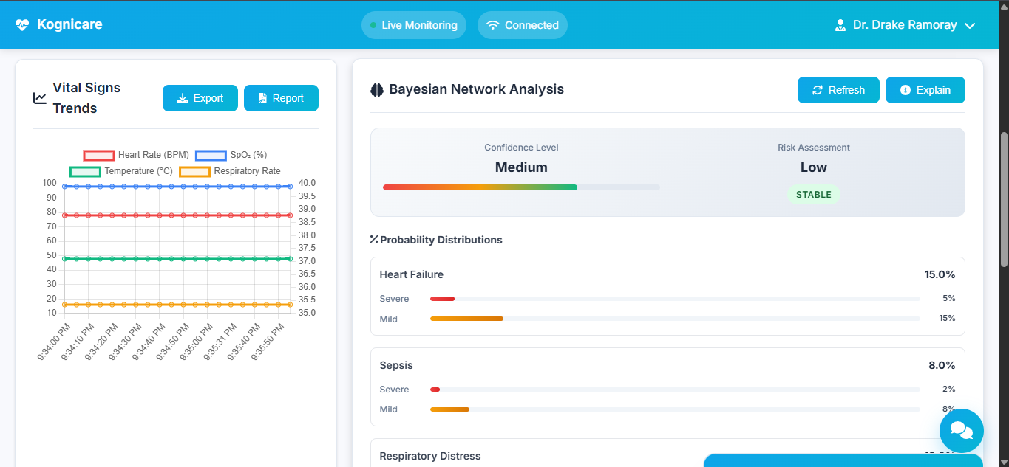
Figure 5.2 – Vital Signs Trends and Bayesian Network Analysis

25
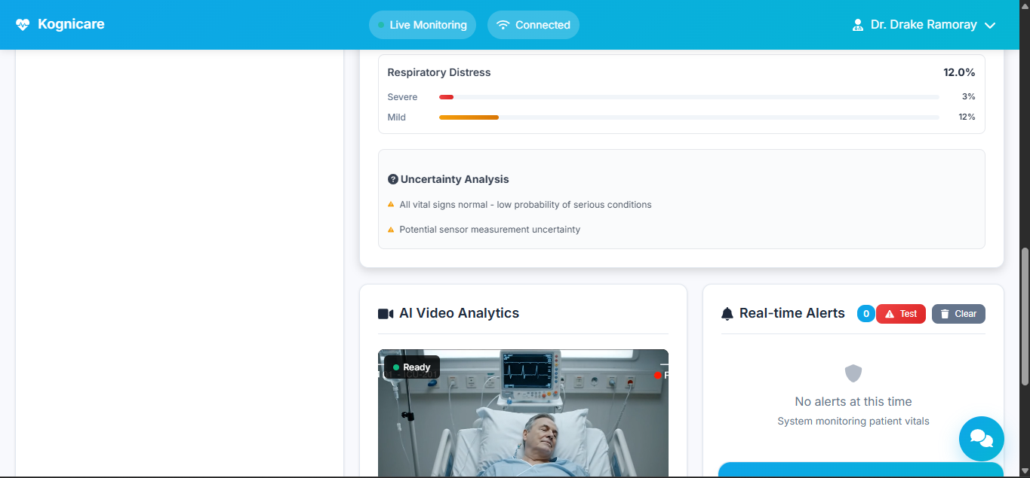
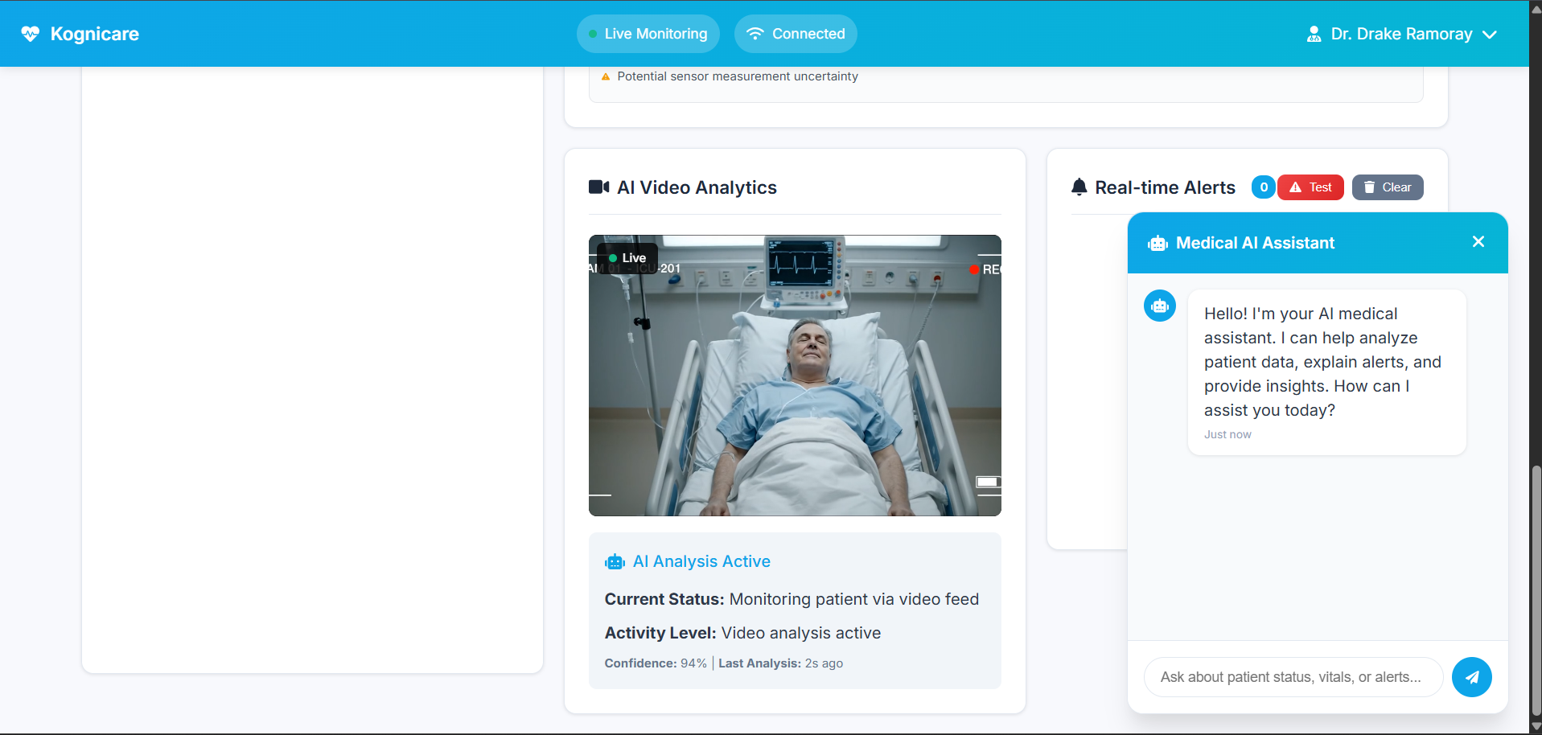
Figure 5.3 and 5.4 – AI Video Analytics and Real Time Alerts

26
- CONCLUSION

The project “KogniCare – AI-Integrated Patient Monitoring System” successfully demonstrates how Artificial Intelligence and Bayesian probabilistic reasoning can be applied to healthcare monitoring for intelligent, real-time medical diagnosis under uncertainty.
Through the integration of Bayesian Networks, uncertainty quantification, and LLM-based medical assistance, the system effectively manages incomplete or noisy data and provides explainable, confidence-aware recommendations. This enhances the reliability of medical decision-making while minimizing false alarms and improving patient safety.
The project also emphasizes transparency, scalability, and academic value, serving as a practical demonstration of probabilistic reasoning and uncertainty management in AI-driven healthcare systems.
Overall, KogniCare lays a strong foundation for future advancements in real-time patient monitoring, AI-assisted diagnosis, and intelligent healthcare technologies.

27
- BIBLIOGRAPHY

- Judea Pearl, Probabilistic Reasoning in Intelligent Systems: Networks of Plausible Inference, Morgan Kaufmann Publishers, 1988.
- Koller, Daphne & Friedman, Nir, Probabilistic Graphical Models: Principles and Techniques, MIT Press, 2009.
- Russell, Stuart & Norvig, Peter, Artificial Intelligence: A Modern Approach, 4th Edition, Pearson Education, 2020.
- Heckerman, David, “A Tutorial on Learning with Bayesian Networks,” Microsoft Research Technical Report MSR-TR-95-06, 1995.
- Zhou, X., et al., “Bayesian Networks in Medical Applications,” Artificial Intelligence in Medicine, Elsevier, 2014.
- World Health Organization (WHO) – “Artificial Intelligence in Health: Ethics and Governance,” WHO Guidance, 2021.
- OpenAI & Microsoft Research, “Large Language Models for Healthcare Decision Support,” AI in Medicine Journal, 2023.
- Flask Documentation, https://flask.palletsprojects.com/
- Chart.js Documentation, https://www.chartjs.org/
- ReportLab User Guide, https://www.reportlab.com/docs/reportlab-userguide.pdf

28

